**Haramball**

**User Manual**

**By: Hannah Munoz**

**Connor Scully-Allison**

**Kurt Andersen**

**Build Instuctions:**

To run Haramball, ensure that you are in the proper build directory [PA10/build] and compile the code as follows.

cd build

cmake ..

make

To begin playing Haramball, enter the following command:

./Haramball

A new window should appear with the pinball table ready to start. The number of balls left will be displayed on the upper left of the table. The score will be displayed in the terminal once the game has ended and the user has run out of balls.

If you make a top 10 score you will be prompted to input your name at the end of the game in the terminal.

**Keyboard Inputs**:

**TO AVOID A STICKY SITUATION**(avoiding sticky keys) do not press shift and then any of the arrow keys 5 times consecutively.

*Game Controls:*

Spacebar - press and hold to add force to launch the ball, release to launch ball. - see image 1

Left shift – moves left paddle, press and hold to stay in up position. - see image 2

Right shift – moves right paddle, press and hold to stay in up position. - see image 3

Esc – Quits the game.

*Camera Controls:*

Left Arrow – pans the camera to the left.

Right Arrow – pans the camera to the right.

Up Arrow – pans the camera upwards.

Down Arrow – pans the camera downwards.

*'r' –* reset camera position.

*Shader Controls:*

'p' – switch to Phong shading. - see image 2/3

'g' – switch to Gourand shading. - see image 4

*Numpad Controls:*

'0' – increases specularity on table. - see image 5

'.' - decreases specularity on table. - see image 5

'1' – increases bumper specularity. - see image 6

'2' – decreases bumper specularity. - see image 6

'4' – increases ball specularity. - see image 7

'5' – decrease ball specularity. - see image 7

'7' – increases flipper specularity. - see image 8

'8' – decrease flipper specularity. - see image 8

'6' – decrease spotlight height. - see image 9

'9' – increase spotlight height. - see image 9

'+' - increase ambient lighting. - see image 10

'-' - decrease ambient lighting. - see image 10

'*' - increase spotlight ambient lighting. - see image 11

‘'/' - decrease spotlight ambient lighting. - see image 11

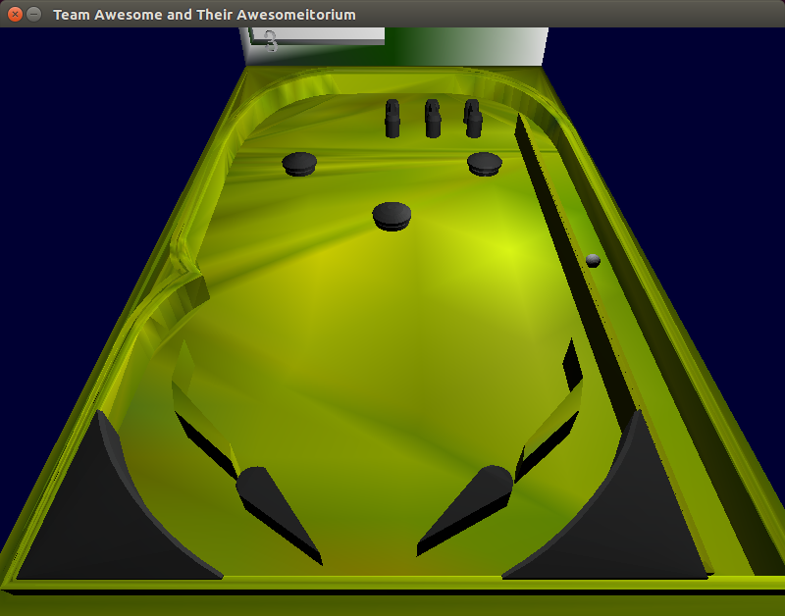Image 1 -

Image 2 -

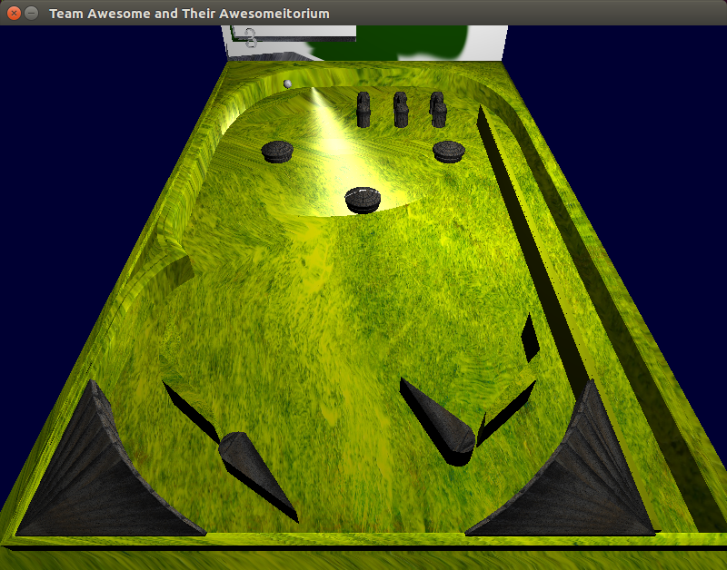

Image 3 -

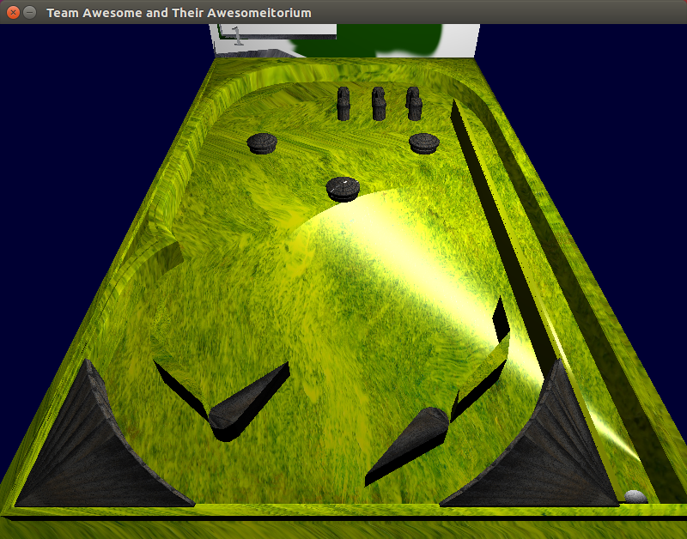

Image 4 -

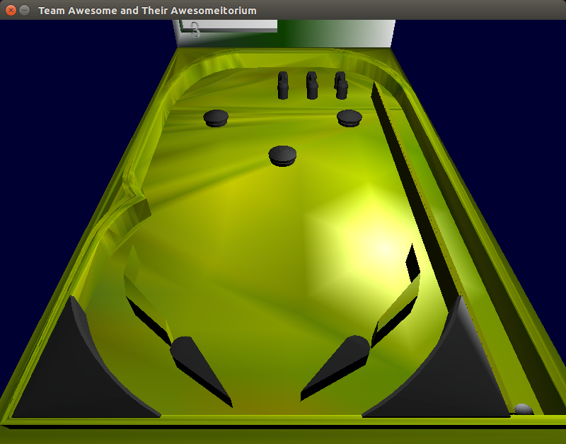

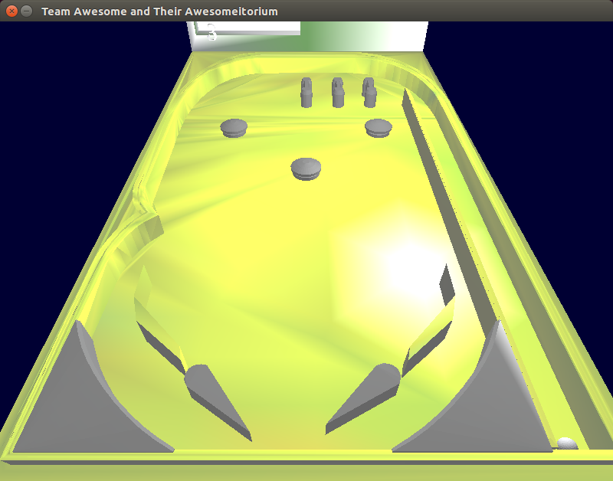Image 5 -

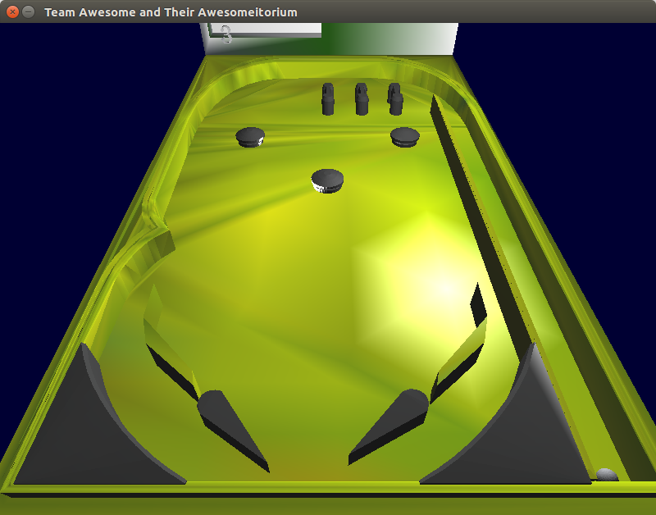Image 6 -

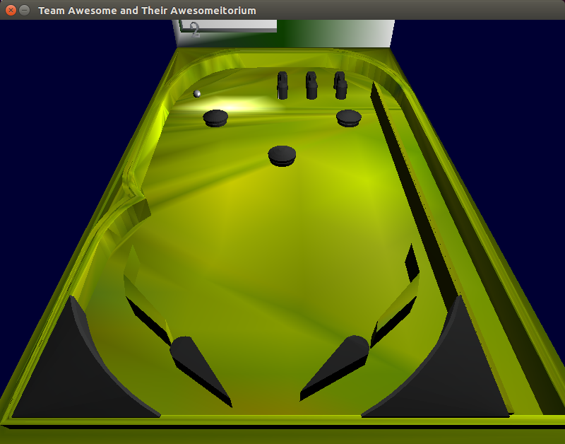Image 7 -

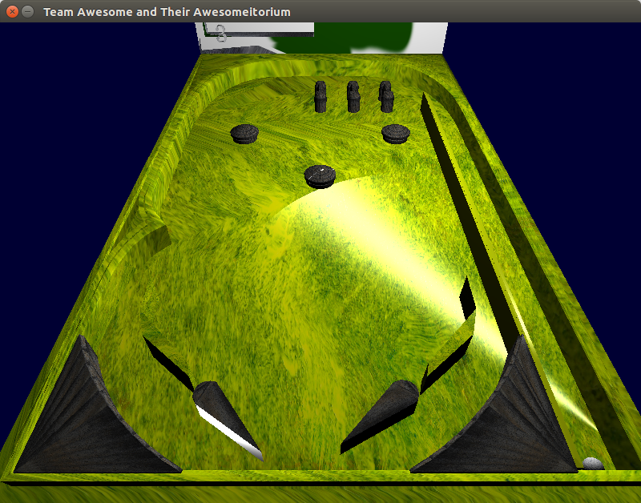Image 8 -

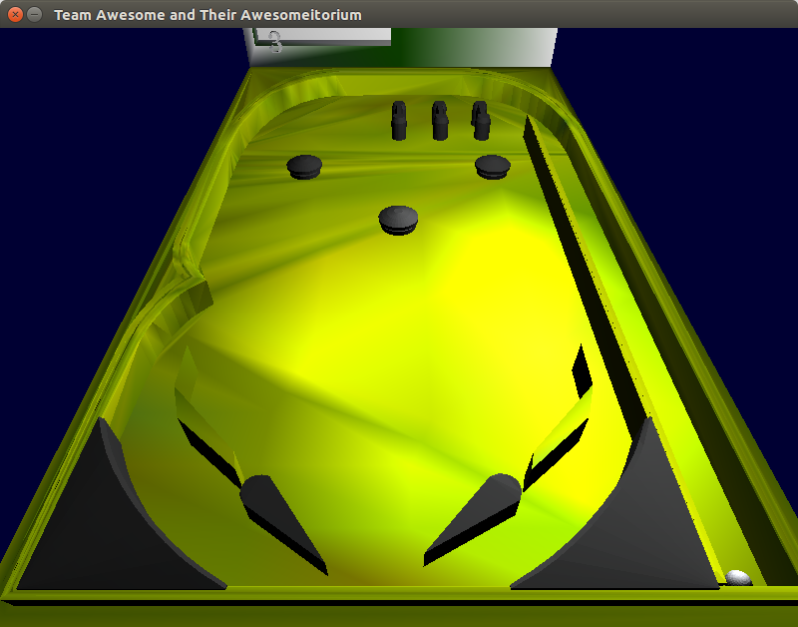Image 9 -

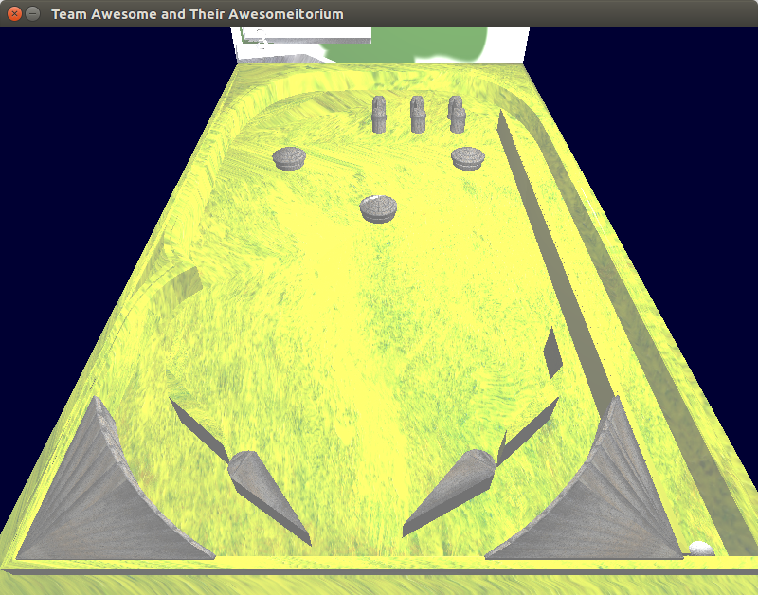Image 10 -

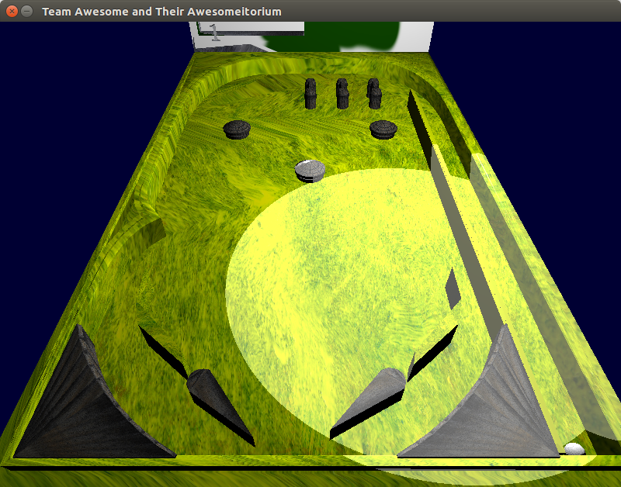

Image 11 -